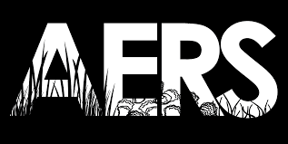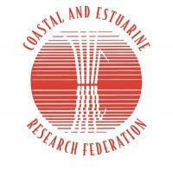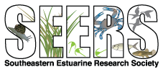

7:45 – 8:00am ET Access virtual meeting platform and prepare to launch workshop

8:00 – 8:15am ET Welcome, Housekeeping, and Introductions
Welcome by TCS (Tom Bigford, NOAA retired and TCS Board member), AERS (Ben Fertig, Stevenson University and AERS President), and SEERS (Enrique Reyes, East Carolina University and SEERS President), and ECU representative Joe Luczkovich
Logistics and Webinar Housekeeping tips

8:15 – 9:05am ET Keynotes: Shifting Opportunities and Pathways
Moderator – Geno Olmi, NOAA Ocean Service and TCS Board Member
- Joe Luczkovich (ECU, Professor of Biology)
- Steve MacLeod (TCS, President)
- Lyndie Hice-Dunton (Responsible Offshore Science Alliance, Executive Director)
- Tyler Peacock (Nutrien, Environmental Scientist)

9:05 – 9:15am ET Break & Optional Virtual Networking

9:15 – 10:30am ET Skill Building Session I
Moderator – Tom Bigford, NOAA Retired and TCS Board Member
Lightning Presentations by each breakout topic leader
- Breakout A: Proposal and Grant Writing – Mike DeLuca, Rutgers
- Breakout B: Federal Service and Navigating USA Jobs – Geno Olmi, NOAA/Ocean Service and TCS Board member
- Breakout C: Getting Your Resume to the Right Person and Then Nailing the Interview – Nicole Rodi, TCS Member

10:30 – 10:40am ET Break & Optional Virtual Networking

10:40 – 11:55am ET Skill Building Session II
Moderator – Geno Olmi, NOAA Ocean Service and TCS Board Member
Lightning Presentations
- Breakout D: Work in the Private/NGO Sector – Meredith Comi, NY/NJ Baykeeper
- Breakout E: Establishing Solid Mentor-Mentee Relationships – Marie Delorenzo, NOAA National Ocean Service
- Breakout F: Lean into the Awkward - Effective Networking – Ben Fertig, Stevenson University and AERS President

11:55 – 12:15pm Final Q&A, Wrap Up & Future Opportunities
Final thoughts
Reminder to complete the post-workshop survey
How to connect with your new mentor
Review future TCS offerings
Wrap up and gratitude moment

